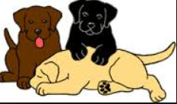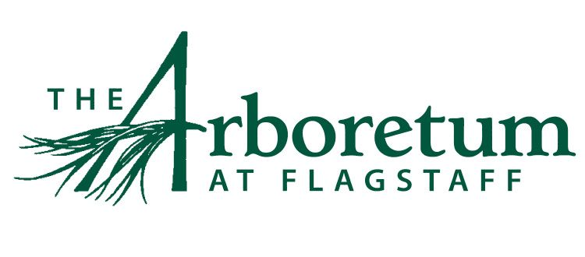
DOG POLICY & WAIVER
The Arboretum at Flagstaff will now allow visitors to bring dogs with them to visit. Your visit helps support our mission of planting and conserving trees and other plants for a greener, healthier, and more beautiful world. This is a trial basis as we must determine the overall cost and level of maintenance required to afford this luxury. In order for this to be successful, both dog owners and dogs must abide by these rules. Please have a talk to your dog(s) and be mindful of what you leave behind.
Therefore, to minimize cost, we have added the following policies.
- Admission will be $2.50 per dog. No exceptions.
- Dog Waste bags will be handed out to each dog owner.
- Dogs must be attended and in control of the owner and on a leash at all times.
- Dogs who become a nuisance, such as excessive barking and disturbance to others, may be asked to leave
- The leash must be no longer than 6 feet
- All dogs must have updated vaccinations and registrations.
- Dogs may not go off the marked trails for the safety of others and the natural environment.
- Dogs must not relieve themselves on plants, trees or in gardens. They must only use marked trails.
- Owners must clean up after your pet.
  - Bags will be handed out at the Visitor Center.
  - Tie the bag off once it is full
  - Dispose of the bag in the trash containers that are dispersed around the grounds
- Due to confined spaces, dogs are not allowed in the following locations:
  - Walter Reichardt House
  - Horticulture building and Resaerch Greenhouses
- Dogs are only allowed during regular business hours, not during special events such as Concerts, Wildflower Walks, Pumpkin Walk, Weddings, etc.
By bringing your dog onto The Arboretum at Flagstaff’s property, you agree to hold the Arboretum, their members, directors, officers, agents, volunteers and employees harmless from any claim for loss or injury that may be alleged to have been caused directly or indirectly to any person or thing by the act of other persons, animals of the wild, owners, guardians, and/or their dog(s) while in or upon the grounds.

YOU assume all responsibility and liability for any such claim; and YOU further agree to hold the aforementioned parties harmless from any claim for loss of your dog(s) by disappearance, theft, death or otherwise, and from any claim for damage or injury to our dog(s), whether such loss, disappearance, theft, damage or injury, be caused or alleged to be caused by the negligence of the Arboretum at Flagstaff or any of the parties aforementioned, or by the negligence of any other person, or any other cause or causes.

Potential Risks:
Risks may include, but are not limited to, injury or damage caused directly or indirectly as a result of dog fights, dog bites, wild animal bites or fights, being knocked down, chased or tripped, dog(s) being hit by a motor vehicle, etc. The dog owner is solely responsible for any and all damages incurred as a result of their dog(s).

