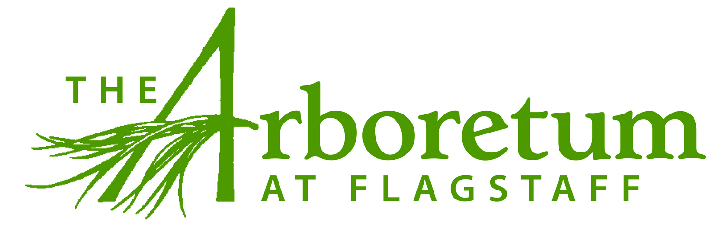

This is an excellent opportunity to work in a beautiful environment with dedicated staff while building your skills and abilities!

Job Title: Communications Intern
Reports to: Director of Communications and Development
Job Category: Part-time seasonal unpaid internship
Schedule: 15-20 hours per week, March - November. Weekends frequent. Open to beginning earlier.

DESCRIPTION:
The Arboretum at Flagstaff works to connect people to the natural environment of the Colorado Plateau through a variety of daily activities, programs, and special events on our 200 acre grounds. The position of Marketing and Special Events Intern will assist in promoting The Arboretum's mission, encouraging connection and recognition within the community via a variety of print, radio and digital advertising channels, and community outreach and engagement. In addition this position will help coordinate activities, programs and events throughout the open season working with multiple departments.

RESPONSIBILITIES:

Marketing/PR
- Manage the listings of all events and activities on all local community calendars as they evolve
- Maintain and update the Arboretum website as needed
- Assist with general office tasks including large mailings, print jobs, and update email contacts
- Distribute posters and fliers for special events and programs
- Assist with social media advertising and daily postings to Facebook
- Assist in fundraising and development for organization as a whole and for specific events, and attend any required committee meetings
- Manage photographs in shared files; take current photos as needed
- Graphic Design experience and ability strongly preferred

Events/Programs
Assist in the planning and execution of special events, activities and programs including, but not limited to, the Summer Soiree fundraiser, Plant Sales, Summer Concert Series, Wine in the Woods, Pumpkin Walk, Festival of Trees, Summer Camps and more. You may also be invited to attend any required event committee meetings.

EDUCATION and EXPERIENCE
- High School diploma
- Two years of college marketing, public programs, business, graphic design or related courses
- A valid driver's license and reliable transportation are required

PREFERRED KNOWLEDGE, SKILLS AND ABILITIES
- Knowledge of Microsoft Excel, Word, Google Drive, Wordpress
- Knowledge of Adobe Creative Suite programs a plus
- Graphic Design knowledge and ability strongly preferred
- Superior organizational and communication skills
- Promptness and dependability
- Willingness and ability to learn new tasks and work with others; initiative for independent work
- A passion for nature, sustainability and conservation
- Willing and able to work with a diverse and vibrant staff and community

COMPENSATION
Robust experience in all areas of Communications, Design, Event Management and more
Unpaid internship with the opportunity for college course credits.
Access to great networking opportunities within the Flagstaff community.
On-the-job, one-on-one learning experience with Director of Communications within a non-profit organization and access to other educational opportunities.
Experience and enjoy all of the fabulous events we put on each year as well as the beautiful gardens at the Arboretum.

TO APPLY
E-mail resume, and two reference contacts to:
Victoria Leone
Director of Communications and Development
Victoria.leone@thearb.org
(928) 774-1442 Extension 124

