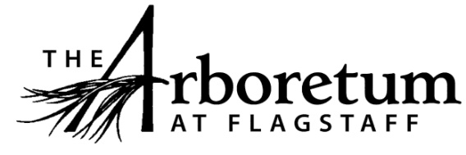
Updated March 2019

Job Title: Director of Public Programs and Education
Reports to: Executive Director
Supervises: Contract educators, interns, volunteers
Job Category: Permanent, 30-35 hours/week

RESPONSIBILITIES
Responsible for the development, coordination, and operation of public programs. Must be able to work some weekends. Duties include, but are not limited to:

Adult and Family Education Programs
- Coordinates and books educational series, presentations, and events, including
  - Mushroom Weekend
  - Pumpkin Walk
  - Festival of Science Open House
  - Wildflower Walks
- Works with Volunteer and Tour Coordinator to organize Docent Training Program
- Gives special tours as needed
- Assists with development of lectures and programs for the greater community, such as the Winter Workshop Series

Community Outreach and Development
- Maintains and coordinates Arboretum participation in community events, such as Science in the Park, Earth Day festival, and Community STEM Celebration
- Assists with development of materials and activities for outreach events
- Develops and maintains community partnerships
- Assists with grant proposals and fundraising opportunities as applicable
- Assists with marketing for youth education and public programs as needed

Youth Education Programs
- Development, assessment, and implementation of educational programming, including curriculum review and development
- Works with Volunteer and Tour Coordinator to promote and coordinate school field trips and in-school programs
  - Leading school trips and in-school programs as needed
- Oversees summer camp registration and daily summer camp operations
- Coordinates summer camp schedule
- Recruits and hires summer camp educators, interns, and presenters as needed
- Trains and supervises summer camp staff, field trip leaders, and interns as needed

EDUCATION AND EXPERIENCE
- College degree in education, environmental studies, or related field
- Experience organizing events and programs
- Two years of related teaching experience
- Experience supervising staff, interns, volunteers
- Knowledge of Colorado Plateau ecology a plus

KNOWLEDGE, SKILLS, AND ABILITIES
- Excellent interpersonal and customer service skills
- Excellent computer skills: MS Office
- Ability to work in challenging, fast-paced environment
- Ability to work as part of a team
- Ability to demonstrate initiative, establish priorities, and meet deadlines
- Must be able to work some weekends and evenings
- Must have valid AZ Driver’s License

SALARY: $17-$19/hour, plus sick leave, holiday pay, and paid vacation

EMAIL Cover Letter and Resume to:
Lynne Nemeth, Executive Director
Lynne.Nemeth@thearb.org

